1. Which are the top three variables in your model which contribute most towards the probability of a lead getting converted?

Answer: Tags, Lead Quality, Time Spent on Website.

1. What are the top 3 categorical/dummy variables in the model which should be focused the most on in order to increase the probability of lead conversion?

Answer: Tags, Lead Quality, Last Notable Activity.

1. X Education has a period of 2 months every year during which they hire some interns. The sales team, in particular, has around 10 interns allotted to them. So during this phase, they wish to make the lead conversion more aggressive. So they want almost all of the potential leads (i.e. the customers who have been predicted as 1 by the model) to be converted and hence, want to make phone calls to as many of such people as possible. Suggest a good strategy they should employ at this stage.

Answer: Due to the illustration below, the customers had a negative relationship with calling strategy. Hence, we need another appropriate strategy which I recommend to investigate the way to more properly tagging the customer since tagging category is the most vital feature to determine the ability to lead conversion.

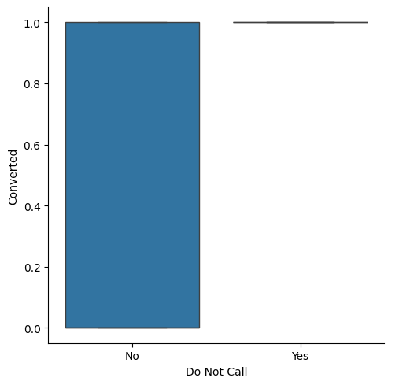

1. Similarly, at times, the company reaches its target for a quarter before the deadline. During this time, the company wants the sales team to focus on some new work as well. So during this time, the company’s aim is to not make phone calls unless it’s extremely necessary, i.e. they want to minimize the rate of useless phone calls. Suggest a strategy they should employ at this stage.

Answers: It's a much better idea as we should focus on the lead source such as google, total time spent on website, pageviews per visit and especially their occupation. This is because the majority of people that get to our website from google and the most crucial factor is that those people tend to spend a lot of time on the platform to search.To be more detailed, they search the information through many pages that are related to their major or domain. Due to the fact that they need this course for finding a job as currently they are unemployed, they have a strong intend to learning (converted).